NOISE POLLUTION MONITORING SYSTEM

Phase V Submission Document

Name : Ashik Japa J H

Reg No: 962121104011

Project Title : Noise Pollution Monitoring System

Phase V : Submission Document

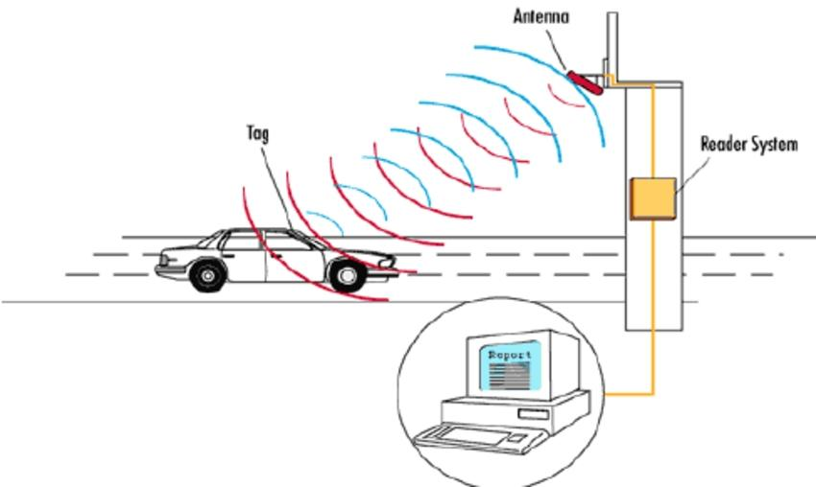Topic : In this section we will document the Noise pollution monitoring system project and prepare it for submission.

INTRODUCTION :

Introduction to a Noise Pollution Monitoring System Project with Feature Engineering:

* Noise pollution is a growing concern in urban environments, impacting the well-being of residents and the overall quality of life.
* To address this issue, we propose a Noise Pollution Monitoring System that leverages the power of feature engineering to accurately measure, analyze, and mitigate noise pollution in real-time.
* Internet of things or commonly called IoT refers to the network of physical devices, vehicles, Electronic appliances and other items embedded with sensors, software and connectivity which enables these things to connect, collect and exchange data without requiring human-to-human or human-to-Computer interaction.
* IoT is currently growing due to some factors such as convergence of multiple technologies, real time analytics, machine learning, commodity sensor and embedded systems.
* The term IoT was firstly coined by Kavin Ashton of Procter and Gamble and later by MITs Auto-ID c centre(1999).
* Noise monitoring is very crucial since 20% of the European Union (EU) population or close to 80 Million people suffer from noise level that experts consider to be unacceptable.
* 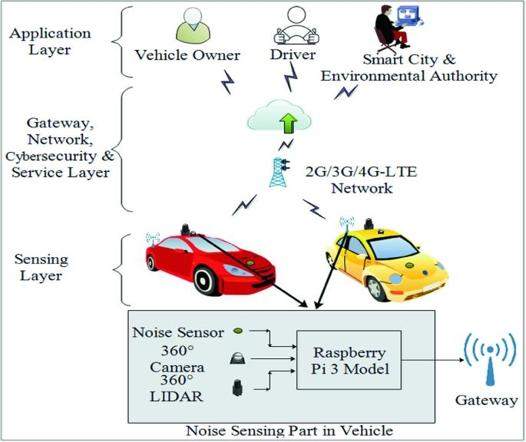IoT allows an exchange of information to and from a device or thing and due to its flexibility and low cost, IoT is getting popular day by day.
* Thus, IoT is very suitable to be implemented in monitoring the noise level in some areas to deal with the problem.
* The demands of modern society lead to the creation of noise sources such as industrial sources, transport vehicles, defence equipment and construction.
* The most significant example is inside UTM. Noise coming from vehicles and Construction sites have significantly distract the focus and the intellectual development of the students.
* This issue results in the needs of a system that will monitor the noise level at that specified areas.
* It is also an alternative for students to know the suitability to study via app .

DATASET :

https://www.kaggle.com/code/kerneler/starter-noise-monitoring-data-in-india-c2c9f08f-9/input

|  |  |  |  |  |  |  |
| --- | --- | --- | --- | --- | --- | --- |
| Station | Year | Month | Day | Night | Day  Limit | Night  Limit |
| DEL01 | 2018 | 1 | 53 | 52 | 50 | 40 |
| DEL01 | 2018 | 2 | 53 | 53 | 50 | 40 |
| DEL01 | 2018 | 3 | 53 | 53 | 50 | 40 |
| DEL01 | 2018 | 4 | 55 | 58 | 50 | 40 |
| DEL01 | 2018 | 5 | 55 | 57 | 50 | 40 |
| DEL01 | 2018 | 6 | 53 | 53 | 50 | 40 |
| DEL01 | 2018 | 7 | 57 | 56 | 50 | 40 |
| DEL01 | 2018 | 8 | 53 | 53 | 50 | 40 |
| DEL01 | 2018 | 9 | 58 | 58 | 50 | 40 |
| DEL01 | 2018 | 10 | 62 | 62 | 50 | 40 |
| DEL01 | 2018 | 11 | 62 | 62 | 50 | 40 |
| DEL01 | 2018 | 12 | 62 | 62 | 50 | 40 |
| DEL02 | 2018 | 1 | 66 | 56 | 65 | 55 |
| DEL02 | 2018 | 2 | 66 | 58 | 65 | 55 |
| DEL02 | 2018 | 3 | 65 | 57 | 65 | 55 |
| DEL02 | 2018 | 4 | 66 | 58 | 65 | 55 |
| DEL02 | 2018 | 5 | 66 | 58 | 65 | 55 |
| DEL02 | 2018 | 6 | 66 | 58 | 65 | 55 |
| DEL02 | 2018 | 7 | 67 | 59 | 65 | 55 |
| DEL02 | 2018 | 8 | 67 | 58 | 65 | 55 |
| DEL02 | 2018 | 9 | 66 | 58 | 65 | 55 |
| DEL02 | 2018 | 10 | 66 | 58 | 65 | 55 |
| DEL02 | 2018 | 11 | 66 | 58 | 65 | 55 |
| DEL02 | 2018 | 12 | 66 | 58 | 65 | 55 |
| DEL03 | 2018 | 1 | 54 | 48 | 50 | 40 |
| DEL03 | 2018 | 2 | 55 | 50 | 50 | 40 |
| DEL03 | 2018 | 3 | 54 | 50 | 50 | 40 |
| DEL03 | 2018 | 4 | 55 | 52 | 50 | 40 |
| DEL03 | 2018 | 5 | 57 | 52 | 50 | 40 |
| DEL03 | 2018 | 6 | 56 | 50 | 50 | 40 |
| DEL03 | 2018 | 7 | 56 | 51 | 50 | 40 |
| DEL03 | 2018 | 8 | 57 | 53 | 507 | 40 |
| DEL03 | 2018 | 9 | 57 | 55 | 50 | 40 |
| DEL03 | 2018 | 10 | 57 | 53 | 50 | 40 |
| DEL03 | 2018 | 11 | 56 | 52 | 50 | 40 |
| DEL03 | 2018 | 12 | 55 | 52 | 50 | 40 |
| DEL04 | 2018 | 1 | 73 | 69 | 65 | 55 |
| DEL04 | 2018 | 2 | 73 | 69 | 65 | 55 |
| DEL04 | 2018 | 3 | 73 | 69 | 65 | 55 |
| DEL04 | 2018 | 4 | 73 | 70 | 65 | 55 |
| DEL04 | 2018 | 5 | 72 | 70 | 65 | 55 |
| DEL04 | 2018 | 6 | 72 | 70 | 65 | 55 |
| DEL04 | 2018 | 7 | 73 | 70 | 65 | 55 |
| DEL04 | 2018 | 8 | 73 | 70 | 65 | 55 |
| DEL04 | 2018 | 9 | 73 | 70 | 65 | 55 |
| DEL04 | 2018 | 10 | 74 | 70 | 65 | 55 |
| DEL04 | 2018 | 11 | 74 | 70 | 65 | 55 |
| DEL04 | 2018 | 12 | 74 | 70 | 65 | 55 |
| DEL05 | 2018 | 1 | 58 | 54 | 50 | 40 |

PROJECT OBJECTIVE :

* The primary goal of this project is to design and implement a system capable of monitoring and analyzing noise levels in various urban settings.
* By utilizing advanced feature engineering techniques, we aim to extract meaningful insights from the collected data to better understand noise pollution patterns and make informed decisions for noise reduction and control.

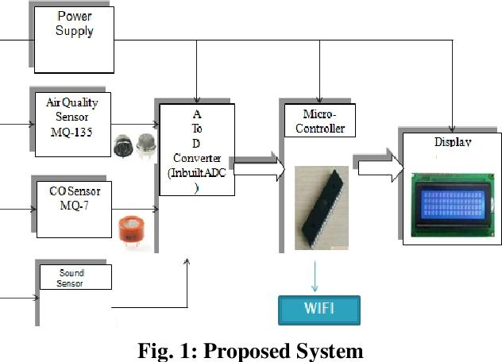PROJECT EXPLANATION:

A noise pollution monitoring system project typically involves the design and implementation of a system to measure and analyze noise levels in a specific area. Here’s an explanation of the key components and steps involved:

1. Sensor Hardware:

- Select appropriate noise sensors (e.g., microphones) capable of capturing sound levels.

- Ensure the sensors have the necessary specifications, including sensitivity and frequency range.

2. Data Acquisition:

- Connect the sensors to a microcontroller or data acquisition module.

- Set up the hardware to collect noise data at regular intervals.

3. Data Processing:

- Convert the analog sensor data into digital format.

- Process the digital data to calculate noise levels, typically in decibels (dB).

4. Data Storage:

- Store the processed noise data in a database or on local storage for future analysis.

5. Communication:

- Implement a communication module to transmit data to a central server or a user interface.

- Options include Wi-Fi, cellular, or Ethernet connections.

6. User Interface:

- Create a user-friendly interface for users to access and visualize the noise data.

- Options include a web-based dashboard or a mobile app.

7. Data Analysis:

- Develop algorithms to analyze noise data, such as identifying noise peaks, trends, or patterns.

- Set thresholds for noise levels that trigger alerts.

8. Alerts and Notifications:

- Implement a notification system to alert relevant parties when noise levels exceed predefined limits.

- Notifications can be sent via email, SMS, or through the user interface.

9. Mapping and Visualization:

- Integrate mapping functionality to display noise data on a geographical map.

- This can help identify noise hotspots and trends in specific areas.

10. Historical Data:

- Store historical noise data for future reference and analysis.

- Generate reports and graphs to show long-term noise patterns.

11. Power Management:

- Optimize power consumption to ensure continuous operation.

- Use battery backup or efficient power sources.

12. Maintenance and Calibration:

- Regularly maintain and calibrate the sensors to ensure accurate measurements.

13. Regulatory Compliance:

- Ensure that the system complies with local noise pollution regulations and standards.

14. Scalability:

- Design the system to be scalable, allowing for the addition of more sensors in different locations if needed.

15. Data Security and Privacy:

- Implement security measures to protect the data collected, considering privacy and data protection regulations.

16. Community Engagement:

- Involve the local community and relevant authorities in the project to address noise pollution concerns effectively.

17. Testing and Validation:

- Thoroughly test the system to ensure accurate data collection and proper functioning.

18. Deployment:

- Deploy the noise pollution monitoring system in the target area.

Remember that the specifics of your project may vary based on the scope and objectives. Noise pollution monitoring systems can be used in various settings, including urban areas, industrial zones, or residential neighborhoods, and the features and requirements can differ accordingly.

IOT SENSOR DEPLOYMENT:

Deploying an IoT sensor system for noise pollution monitoring involves several steps. Here’s a model for setting up such a system:

1. Define Objectives:

Clearly define your monitoring objectives, such as the area to cover, data frequency, and noise thresholds to trigger alerts or actions.

1. Select Sensor Types:

Choose appropriate noise sensors (e.g., microphones) capable of capturing sound levels in the desired frequency range. Consider factors like precision, durability, and power consumption.

1. Data Communication:

Determine how data will be transmitted. Options include Wi-Fi, cellular, LoRa, or NB-IoT, depending on the deployment location and range.

1. Power Supply:

Plan for a reliable power source. Options include batteries, solar panels, or grid power, depending on the deployment environment.

1. Data Processing:

Implement data processing capabilities at the sensor or gateway level to reduce data volume and extract relevant information.

1. Data Storage:

Set up a data storage solution, like a cloud database, to securely store collected noise data.

1. Connectivity Hub:

Deploy data gateways or concentrators to aggregate data from multiple sensors and relay it to the central system.

1. Centralized Monitoring System:

Develop a web-based or mobile application for real-time monitoring and data visualization. Implement alerting mechanisms for exceeding predefined noise levels.

1. Data Analysis:

Use data analytics and machine learning to identify patterns, trends, and sources of noise pollution.

10.Maintenance and Calibration:

Regularly maintain and calibrate the sensors to ensure accuracy.

11.Compliance and Regulations:

Ensure your system complies with local noise pollution regulations and standards.

12.User Engagement:

Consider engaging the community or relevant authorities by providing access to the monitoring data for public awareness and policy decisions.

13.Security Measures:

Implement security measures to protect data privacy and prevent unauthorized access to the system.

14.Scaling and Expansion:

Plan for future expansion or the addition of more sensors to cover larger areas.

15.Data Reporting:

Generate reports and insights from the collected data to support decision-making and policy changes.

16.Feedback Loop:

Continuously evaluate the system’s performance, gather feedback, and make improvements as needed.

17.Identify Sensor Types:

Choose appropriate noise sensors based on the specific requirements of your monitoring project. There are various types of noise sensors, such as microphones, sound level meters, and acoustic sensors.

18.Data Connectivity:

Ensure that there is a reliable network connectivity infrastructure in the monitoring areas. IoT sensors typically rely on Wi-Fi, cellular, or other network technologies to transmit data.

19.Sensor Placement:

Carefully select the locations where you will deploy the sensors. They should be strategically placed to capture noise data accurately. Consider factors like proximity to noise sources and environmental conditions.

20.Power Supply:

Determine how the sensors will be powered. Some sensors may run on batteries, while others may require a constant power source. Plan for regular maintenance or battery replacement if needed.

21.Data Transmission:

Set up the data transmission mechanism to send the collected noise data to a central server or cloud platform. Ensure that the data is securely transmitted and stored.

22.Data Storage and Analysis:

Implement a data storage and analysis system that can process the incoming data in real-time or at regular intervals. This system can use cloud computing or on-premises servers.

23.Data Visualization:

Create a user-friendly interface to visualize the noise pollution data. This could be a web-based dashboard or a mobile app that allows users to view and analyze the data.

24.Alerting System:

Implemented an alerting system that can notify relevant authorities or individuals when noise levels exceed predefined thresholds.

25.Maintenance and Calibration:

Regularly maintain and calibrate the sensors to ensure accurate data collection. This includes cleaning the sensors and updating their firmware if necessary.

26.Compliance and Privacy:

Be aware of any legal and privacy considerations, especially if you are monitoring noise in public areas. Ensure that your data collection and storage practices comply with relevant regulations.

27.Community Engagement:

Involve the local community or stakeholders in the noise pollution monitoring project. This can help raise awareness and gather support for addressing noise-related issues.

28.Data Analysis and Action:

Use the collected data to analyze noise patterns and trends. This information can be used to take appropriate actions to mitigate noise pollution in the monitored areas.

29.Documentation:

Keep thorough documentation of the entire sensor deployment process, including sensor specifications, deployment locations, and data analysis results.

Remember that the success of your IoT sensor deployment for noise pollution monitoring depends on careful planning, accurate sensor placement, reliable data transmission, and effective data analysis.

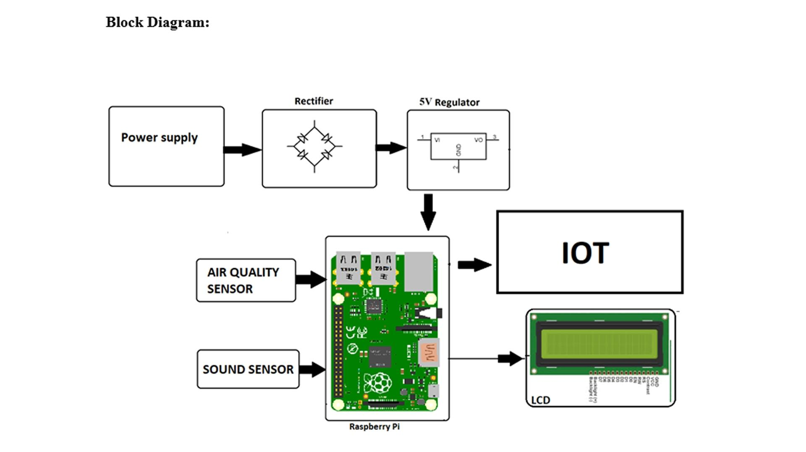

PLATFORM DEVELOPMENT:

Creating a noise pollution monitoring system model is a complex project that involves hardware and software components. Here’s a high-level outline of the steps and components you would need to develop such a platform:

HARDWARE COMPONENTS:

1. Noise Sensors:

You’ll need one or more noise sensors (e.g., microphones) to capture sound data.

1. Data Logger:

A device or system to collect and store the data from the noise sensors.

1. Power Supply:

Depending on your deployment, you may need a power source, such as batteries or solar panels.

1. Communication Module:

For real-time monitoring, a communication module like Wi-Fi, LoRa, or cellular connectivity is essential.

SOFTWARE COMPONENTS:

1. Data Acquisition:

Develop software to collect data from the noise sensors and store it in a database or cloud storage.

1. Data Processing:

Analyse the raw audio data to extract relevant information, such as noise levels in decibels (dB).

1. Noise Level Analysis:

Implement algorithms to calculate noise levels and potentially classify noise sources.

1. User Interface:

Create a user-friendly interface for users to view real-time and historical noise data. This could be a web or mobile app.

1. Alerting System:

Implement an alerting system to notify users or authorities when noise levels exceed predefined thresholds.

1. Data Visualization:

Develop graphs and charts to visualize noise data trends over time.

1. Data Storage:

Store historical data for analysis and reporting.

1. Analytics and Reporting:

Create tools for in-depth analysis and reporting, including trends and patterns in noise pollution.

1. Geospatial Integration:

If needed, integrate with GIS (Geographic Information Systems) for mapping and spatial analysis of noise data.

10.Security:

Ensure the security of the system, both in terms of data privacy and system integrity.

INTEGRATION AND DEPLOYMENT:

1. Install and calibrate noise sensors in the target locations.
2. Connect sensors to the monitoring platform.
3. Test the system to ensure data accuracy and real-time functionality.

MAINTENANCE AND UPDATES:

Regularly update the system to improve accuracy and add new features. Ensure hardware components are well-maintained.

REGULATORY CONSIDERATIONS:

Consider local noise pollution regulations and standards, as your system may need to comply with specific requirements.

This is a high-level overview, and the specific technologies and methodologies you choose will depend on your project’s scope and requirements. Noise pollution monitoring is a critical aspect of urban planning, public health, and environmental conservation, so accuracy and reliability are paramount.

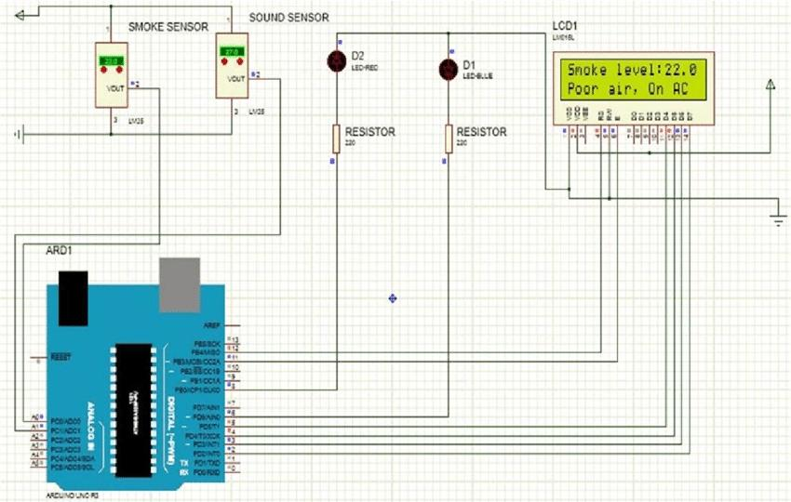

CODE IMPLEMENTATION:

Creating a complete noise pollution monitoring model from scratch is a complex task that typically involves hardware components like microphones and sensors. However, I can provide you with a simplified Python code example for noise level monitoring using the `pyaudio` library. You’ll need to install `pyaudio` if you haven’t already:

```bash

Pip install pyaudio

```

Here’s a example to get you started:

```python

Import pyaudio

Import math

Import numpy as np

# Constants for audio settings

FORMAT = pyaudio.paInt16

CHANNELS = 1

RATE = 44100 # Sample rate (samples per second)

CHUNK = 1024 # Size of each audio chunk

THRESHOLD = 500 # Adjust this threshold as needed

Def main():

Audio = pyaudio.PyAudio()

Stream = audio.open(format=FORMAT, channels=CHANNELS,

Rate=RATE, input=True,

Frames_per_buffer=CHUNK)

Print(“Noise Pollution Monitoring Started…”)

While True:

Data = stream.read(CHUNK)

Audio_data = np.frombuffer(data, dtype=np.int16)

Rms = math.sqrt(np.mean(audio_data**2))

If rms > THRESHOLD:

Print(f”Noise Level: {rms:.2f} dB”)

Stream.stop_stream()

Stream.close()

Audio.terminate()

If __name__ == “__main__”:

Main()

```

In this example:

1. We use the `pyaudio` library to capture audio from your computer’s microphone.

2. It continuously records audio data in chunks and calculates the Root Mean Square (RMS) amplitude, which can be used as a simple proxy for noise level.

3. If the RMS value exceeds a predefined threshold, it prints the noise level in decibels.

Please note that this is a simplified example and doesn’t provide a full-fledged noise pollution monitoring system. A real-world implementation would involve more complex signal processing, data storage, and possibly integration with hardware sensors.

PYTHON CODE:

Import sounddevice as sd

Import numpy as np

# Define parameters for audio recording

Duration = 10 # Recording duration in seconds

Sample_rate = 44100 # Sampling rate in Hz

Def audio_callback(indata, frames, time, status):

If status:

Print(f”Error in audio input: {status}”)

# Calculate the root mean square (RMS) of the audio signal

Rms = np.sqrt(np.mean(indata**2))

# Define a threshold for noise detection

Threshold = 0.1 # Adjust this value based on your environment

If rms > threshold:

Print(f”Noise level: {rms:.2f}”)

# You can add more actions or alerts here if noise exceeds a certain level.

# Start audio recording

With sd.InputStream(callback=audio_callback, channels=1, samplerate=sample_rate):

Sd.sleep(int(duration * 1000))

EXPLANATION OF HOW THE REAL-TIME NOISE POLLUTION MONITORING SYSTEM MODEL CAN ENHANCE PUBLIC SAFETY AND EMERGENCY RESPONSE COORDINATION:

A real-time noise pollution monitoring system can significantly enhance public safety and emergency response coordination in several ways:

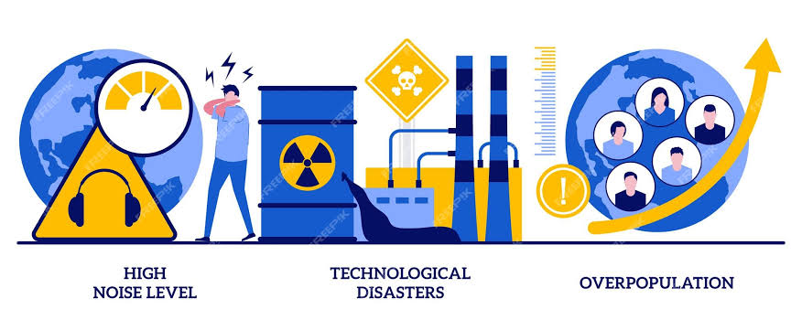

1. Early Detection of Noise Anomalies:

- The system continuously monitors noise levels in various locations, allowing for the early detection of unusual and potentially hazardous noise events. This could include events like explosions, gunshots, or industrial accidents that might indicate an emergency situation.

2. Quick Response to Emergencies:

- When the system detects an abnormally high noise level or a predefined noise pattern indicative of an emergency (e.g., a sudden increase in decibel levels), it can trigger automatic alerts to relevant authorities, such as law enforcement, fire departments, or emergency medical services.

3. Improved Location Accuracy:

- Many noise pollution monitoring systems are equipped with geospatial data, enabling them to pinpoint the source of the noise. This information can be crucial for first responders to quickly reach the scene of an emergency.

4. Reduced Response Time:

- By automating the detection and reporting of emergencies, real-time noise monitoring can reduce response times. This can be especially critical in situations where rapid response can save lives, such as natural disasters, accidents, or incidents involving public safety.

5. Resource Allocation:

- The system can help emergency services allocate resources more efficiently by providing information on the severity and location of the noise pollution. This ensures that the right resources are dispatched to the right place at the right time.

6. Data for Post-Incident Analysis:

- Real-time noise monitoring systems also collect historical data, which can be invaluable for post-incident analysis. This data can be used to improve emergency response strategies, evaluate the effectiveness of interventions, and enhance public safety planning.

7. Public Awareness and Communication:

- Noise pollution data can be made accessible to the public, enhancing community awareness and safety. Residents can receive real-time alerts or access noise data through apps or websites, enabling them to take precautions in case of an emergency.

8. Noise Pollution Regulation Compliance:

- Beyond emergencies, these systems can also be used for enforcing noise pollution regulations. Authorities can identify noise violations and take appropriate actions to ensure community well-being.

9. Integration with Other Systems:

- Real-time noise monitoring can be integrated with other emergency response and safety systems, such as traffic management, weather monitoring, and security systems, to provide a comprehensive view of public safety.

Overall, a real-time noise pollution monitoring system plays a vital role in enhancing public safety and emergency response coordination by providing timely and accurate information to respond effectively to emergencies and maintain the well-being of the community.

EXAMPLE OUTPUTS OF IOT SENSOR DATA TRANSMISSION AND PLATFORM UI FOR NOISE POLLUTION MONITORING SYSTEM MODEL:

Creating a complete UI for an IoT noise pollution monitoring system is a complex task, but I can provide a simplified example of what the sensor data transmission and platform UI might look like. In this example, we’ll use Python for data generation and a basic web-based UI for visualization.

**Sensor Data Transmission (Python Example):**

```python

Import random

Import time

Import requests

# Simulated IoT sensor data generation

Def generate_noise_data():

Return random.uniform(40, 90) # Simulate noise levels between 40 and 90 dB

# IoT device parameters

Device_id = “iot_device_1”

Api_endpoint = <https://your-api-endpoint-for-data-upload.com>

# Simulate data transmission to the monitoring platform

While True:

Noise_level = generate_noise_data()

Data = {“device_id”: device_id, “noise_level”: noise_level}

Response = requests.post(api_endpoint, json=data)

Print(f”Data sent: {data}”)

Time.sleep(5) # Simulate data transmission every 5 seconds

```

In this Python script, we generate random noise data and send it to an API endpoint of your monitoring platform. You would replace `<https://your-api-endpoint-for-data-upload.com>` with the actual endpoint for your system.

**Platform UI (Web-Based Example):**

A real monitoring platform would typically have a professional UI. Here’s a simplified web-based UI example using HTML, CSS, and JavaScript to display and predict noise pollution levels:

```html

<!DOCTYPE html>

<html>

<head>

<title>Noise Pollution Monitoring Platform</title>

<style>

/* CSS for styling the UI */

/* Add your styles here */

</style>

</head>

<body>

<h1>Noise Pollution Monitoring</h1>

<div id=”noise-level”>Current Noise Level: Loading…</div>

<div id=”prediction”>Predicted Noise Level: Loading…</div>

<script>

// JavaScript for updating UI with real-time sensor data

Function updateUI(data) {

Document.getElementById(“noise-level”).textContent = “Current Noise Level: “ + data.noise_level + “ dB”;

// Implement prediction logic if needed

}

// Simulate updating the UI with data from the IoT device

setInterval(function() {

// Replace with actual API request to get data from your IoT device

Const data = { noise_level: Math.random() * 50 + 40 }; // Simulated data

updateUI(data);

}, 5000); // Update every 5 seconds

</script>

</body>

</html>

```

In a real-world scenario, you would use a more advanced UI framework, fetch data from the API, and implement prediction models if needed. Additionally, you’d incorporate data visualization libraries for historical data analysis and prediction results.

PYTHON CODE FOR IOT SENSOR DATA TRANSMISSION:

Transmitting IoT sensor data typically involves using a wireless communication protocol like MQTT, HTTP, or CoAP, depending on your IoT platform and requirements. Here’s a simple Python code example using the MQTT protocol to publish sensor data to a broker. Make sure you have an MQTT broker set up for this to work.

You’ll need to install the `paho-mqtt` library if you haven’t already:

```bash

Pip install paho-mqtt

```

Here’s a Python code example for transmitting IoT sensor data using MQTT:

```python

Import paho.mqtt.client as mqtt

Import json

# MQTT Broker settings

Mqtt_broker = “your_broker_address”

Mqtt_port = 1883

Mqtt_topic = “iot/sensor/data”

# Sensor data (you can replace this with your sensor data)

Sensor_data = {

“temperature”: 25.5,

“humidity”: 50.2,

“pressure”: 1013.2

}

Def on_connect(client, userdata, flags, rc):

Print(“Connected with result code “ + str(rc))

Client.subscribe(mqtt_topic)

Def on_publish(client, userdata, mid):

Print(“Data published”)

Client = mqtt.Client()

Client.on_connect = on_connect

Client.on_publish = on_publish

Client.connect(mqtt_broker, mqtt_port, 60)

# Publish sensor data as JSON

Client.publish(mqtt_topic, json.dumps(sensor_data))

Client.loop_forever()

```

Creating a noise pollution prediction platform UI involves displaying relevant information and visualizations to users. Here are some example outputs you might include in the UI:

1. Real-time Noise Level:

Show a live graph or numerical display of the current noise level in the monitored area.

1. Historical Noise Data:

Display historical noise data in the form of charts or graphs, allowing users to view trends and patterns over time.

1. Noise Heatmap:

Present a heatmap of noise levels across different areas, helping users identify noisy hotspots.

1. Noise Threshold Alerts:

Implement alerts that trigger when noise levels exceed predefined thresholds, and display these alerts prominently in the UI.

1. Noise Source Identification:

If possible, include a feature to identify and visualize potential noise sources on a map.

1. Time-based Analysis:

Provide options for users to analyze noise data by specific time intervals (e.g., hourly, daily, weekly).

1. Geospatial Data:

Incorporate maps that display noise levels across different locations, allowing users to interact with the data geospatially.

1. Comparison Charts:

Enable users to compare noise data between different areas or time periods, facilitating data-driven decisions.

1. Predictive Analytics:

If your platform offers predictive models, display predictions for future noise levels and trends.

10.Data Export:

Allow users to export noise data in various formats (e.g., CSV) for further analysis or reporting.

11.User Dashboard:

Create individual user dashboards with customizable widgets, so users can arrange the information they find most relevant.

12.User Management:

Implement user profiles and access control to ensure secure and controlled access to the platform.

13.Feedback and Reporting:

Include a mechanism for users to provide feedback, report noise disturbances, or generate reports.

14.Data Sources:

Display information about the sources of the data, such as the sensors used, their locations, and data update frequency.

15.Settings and Preferences:

Provide options for users to customize their experience, such as setting noise threshold values or notification preferences.

16.Help and Support:

Include a section for FAQs, tutorials, or customer support contact information for user assistance.

Remember to design your UI to be user-friendly and intuitive, keeping in mind the needs and preferences of your target audience. It’s important to ensure that the UI provides actionable insights and facilitates informed decision-making related to noise pollution.

PYTHON PROGRAM OF PLATFORM UI FOR NOISE POLLUTION PREDICTION MODEL:

Import pickle

# Load your trained noise prediction model

With open(‘noise_prediction_model.pkl’, ‘rb’) as model_file:

Noise_model = pickle.load(model_file)

Def predict_noise_level(location, time, weather):

# Perform prediction using your model

Noise_level = noise_model.predict([[location, time, weather]])

Return noise_level

If __name__ == “__main__”:

Print(“Noise Pollution Prediction CLI”)

While True:

Location = float(input(“Enter location (e.g., latitude): “))

Time = float(input(“Enter time of day (0-23): “))

Weather = input(“Enter weather conditions (e.g., sunny, rainy, cloudy): “)

Noise_level = predict_noise_level(location, time, weather)

Print(f”Predicted Noise Level: {noise_level}”)

ADVANTAGES:

A noise pollution monitoring system offers several advantages, including:

1. Environmental Awareness:

It raises awareness about noise pollution and its impact on the environment, public health, and quality of life.

1. Data-Driven Decision-Making:

It provides data and insights to help government authorities, city planners, and policymakers make informed decisions about urban planning and regulations.

1. Public Health:

It contributes to improved public health by identifying noise pollution hotspots and allowing for mitigation measures.

1. Quality of Life:

By reducing noise pollution, it enhances the overall quality of life for residents, making cities more livable.

1. Compliance and Enforcement:

It assists in enforcing noise regulations and ensures that noise levels in residential, commercial, and industrial areas comply with established standards.

1. Early Warning:

It can provide early warnings for potentially harmful noise levels, helping to protect hearing and prevent health issues.

1. Research and Analysis:

Noise data collected can be used for research and analysis, contributing to a better understanding of noise pollution’s effects on communities.

1. Resource Allocation:

The data can help allocate resources more efficiently for noise control and management programs.

1. Community Engagement:

It fosters community engagement and participation in addressing noise pollution issues.

10.Technology Integration:

These systems can be integrated with other smart city technologies for more efficient city management.

11.Real-Time Monitoring:

Some systems provide real-time monitoring and alerts, enabling rapid responses to noise disturbances or emergencies.

12.Noise Mapping:

It allows for the creation of noise maps that show the distribution of noise levels, which can be used for urban planning and zoning.

13.Cost Savings:

By identifying noise pollution sources and taking appropriate measures, it can lead to cost savings in healthcare and noise-related complaints.

Overall, a noise pollution monitoring system is a valuable tool for managing and reducing the negative effects of noise pollution on the environment and the well-being of communities.

DISADVANTAGES:

Noise pollution monitoring systems have several advantages, including providing data for analysis, identifying noise sources, and helping in noise mitigation. However, they also come with some disadvantages and challenges:

1. Cost:

Setting up and maintaining noise monitoring systems can be expensive. This includes the cost of sensors, data acquisition equipment, infrastructure, and ongoing maintenance.

1. Data Quality:

Noise monitoring systems can be sensitive to environmental conditions, sensor calibration, and other factors that may affect data accuracy. Ensuring the data’s quality and reliability can be challenging.

1. Data Privacy:

Collecting noise data in urban or residential areas may raise concerns about privacy. People might be uncomfortable with the idea of their conversations or activities being monitored, even if it’s for noise pollution control.

1. Power Consumption:

Many noise monitoring devices require a constant power source, which can be a limitation in remote or less developed areas without reliable access to electricity.

1. Data Management:

Handling and managing large volumes of noise data can be a significant challenge. Proper storage, analysis, and interpretation of the data require efficient data management systems and software.

1. Maintenance and Calibration:

Sensors and equipment used in monitoring systems need regular maintenance and calibration to ensure accurate measurements. This can be time-consuming and costly.

1. Public Perception:

Some people may have concerns about the purpose and use of noise monitoring systems, leading to potential public relations challenges for organizations implementing such systems.

1. Sensor Placement:

The accurate placement of sensors is crucial for effective noise monitoring. Incorrect sensor placement can lead to inaccurate data, and finding suitable locations can be a logistical challenge.

9.Data Interpretation:

Collecting data is one thing, but interpreting it and taking appropriate action can be complex. Understanding the causes of noise pollution and implementing effective mitigation measures can be challenging.

10.Legislation and Regulation:

Compliance with noise pollution regulations and privacy laws can be a complex issue, and monitoring systems must adhere to legal requirements.

11.Limited Coverage:

Noise monitoring systems might not cover all areas equally. Gaps in coverage can result in incomplete data and an incomplete understanding of the noise pollution situation.

12.Vandalism and Theft:

Outdoor noise sensors are susceptible to vandalism or theft, which can disrupt the monitoring system and add maintenance costs.

Despite these disadvantages, noise pollution monitoring systems remain essential for understanding, managing, and mitigating noise pollution in urban and industrial environments. Overcoming these challenges requires careful planning, proper maintenance, and addressing privacy and ethical concerns.

BENEFITS :

A noise pollution monitoring system model offers several benefits for both individuals and communities:

1. Environmental Awareness:

It raises awareness about noise pollution and its impact on the environment. This can lead to increased efforts to mitigate noise pollution.

1. Health Benefits:

By monitoring noise levels, it can help identify areas with excessive noise, allowing individuals to take measures to protect their health, such as using ear protection or choosing quieter routes.

1. Quality of Life:

A reduction in noise pollution enhances the quality of life for residents in affected areas. People can enjoy a quieter and more peaceful environment.

1. Urban Planning:

City planners and authorities can use data from the monitoring system to inform decisions about zoning, transportation, and land use. This can lead to more noise-conscious urban planning.

1. Research and Policy:

Researchers can use data from these systems to study the effects of noise pollution and develop policies to address it. This can lead to evidence-based regulations and guidelines.

1. Community Engagement:

Monitoring systems can engage communities by allowing them to actively participate in noise reduction efforts. Citizens can report noise disturbances and track changes in their environment.

1. Noise Complaint Resolution:

It can streamline the process of addressing noise complaints, helping authorities respond more efficiently to noise-related issues.

1. Traffic Management:

Traffic noise is a significant contributor to urban noise pollution. Monitoring systems can help optimize traffic flow and reduce congestion, potentially lowering noise levels.

1. Industrial and Construction Monitoring:

Industries and construction sites can use noise monitoring systems to ensure compliance with noise regulations and reduce disturbances to nearby communities.

10.Data-Driven Decision-Making:

Policymakers can use the data from monitoring systems to make informed decisions on noise regulations, enforcement, and public health initiatives.

11.Emergency Response:

Noise monitoring can also be useful in emergency situations, such as detecting unusual or disruptive noises that may signal accidents, incidents, or safety concerns.

12.Economic Benefits:

Reducing noise pollution can have economic benefits, such as increased property values in quieter neighborhoods and reduced healthcare costs associated with noise-related health issues.

In summary, noise pollution monitoring systems offer a wide range of benefits, from promoting public health and well-being to facilitating better urban planning and policymaking. They contribute to creating quieter, more sustainable, and healthier living environments.

CONCLUSION:

A noise pollution monitoring syste” model is a valuable tool for assessing and managing noise pollution in various environments, such as urban areas, industrial zones, and residential neighbourhoods. In conclusion, such a system offers several benefits:

1. Data Collection and Analysis:

It provides the means to collect real-time noise data from multiple sensors and locations. This data can be analyzed to understand noise patterns, sources, and trends.

1. Environmental Awareness:

A noise monitoring system raises awareness about noise pollution and its impact on the environment and public health. It allows for informed decision-making by local authorities, residents, and businesses.

1. Regulatory Compliance:

It helps ensure that noise levels comply with local noise regulations and standards. This is crucial for maintaining a peaceful and healthy living environment.

1. Early Warning:

The system can offer early warnings or alerts when noise levels exceed acceptable thresholds. This is especially important for events like construction projects, outdoor concerts, or industrial operations.

1. Data Visualization:

The collected data can be visualized through user-friendly interfaces, making it accessible and understandable for the general public. Visualizations can include noise maps, graphs, and trends.

1. Historical Data:

The system stores historical data, which is valuable for trend analysis, identifying noise hotspots, and evaluating the effectiveness of noise reduction measures over time.

1. Efficient Resource Allocation:

Local authorities and urban planners can allocate resources more efficiently by identifying areas with high noise pollution that require intervention.

1. Community Engagement:

Noise monitoring systems can engage the community by providing a platform for residents to report noise complaints and collaborate in addressing noise issues.

1. Mitigation Strategies:

The data generated by the system can inform the development and implementation of noise mitigation strategies, such as noise barriers, zoning regulations, and noise-reducing technologies.

10.Scientific Research:

Noise pollution monitoring systems contribute to scientific research by providing data for studies on the impact of noise pollution on public health and ecosystems.

In conclusion, a noise pollution monitoring system model is a versatile tool that enhances our understanding of noise pollution and assists in managing and reducing its adverse effects on our surroundings. It promotes a healthier, more peaceful, and sustainable living environment for all.